**Number system**

1. Natural numbers N (double line) = {0, 1, 2…}. Sometimes the symbol N₀ is used to indicate that it contains 0.
2. Integers Z (double lined) = {…-3,- 2, -1, 0, 1, 2, 3…}; includes negative numbers
3. mod represents remainder resulting from a division operation. For example, 19 mod 5 = 4
4. a divides b if b mod a = 0. Here a is called a factor of b. It’s mathematically represented as a | b. Thus 4 | 20, 7 | 63 etc. This implies that numbers that are non-factors will leave a remainder during the division operation. These are mathematically represented as a ∤ b.
5. Factors occur in pairs, unless it’s a perfect square. Thus, factors of 12 are {1, 12}, {2, 6} and {3,4}. In the case of perfect square, it’s only one number in the set. For example, {6} is one of the factors of 36.
6. Number is prime if the factors are 1 and the number itself. 1 is not prime.
7. Every number can be decomposed into prime factors. This process is called prime factorization.
8. Rational number can be written as $\frac{p}{q}$, where q is not zero. Q is used to denote the set of all rational numbers. Multiplying numerator and denominator by same number doesn’t change the value.
9. In order to get to the reduced representation of the rational numbers, we’ll divide both numerator and denominator by the GCD/HCF of the numbers.
10. In the case of rational numbers, we can always find another rational that lies in between. This implies rational numbers are dense, while integers are discrete.
11. Square roots of numbers that are not perfect squares is not rational, since it cannot be represented as $\frac{p}{q}$
12. Rational numbers and irrational numbers are together called real numbers (R)
13. Like rational numbers, real numbers are dense. Thus, between any two real numbers, there’s another real number.
14. Square root of a negative number is imaginary, or called complex numbers.
15. 2 is considered to be a prime number.
16. There is no largest prime, and it was proved by Euclid of Alexandria.
17. Prime number theorem states that pi(x) is approximately x/(log(x)) for large values of x. NOTE: pi(x) is a function that outputs all primes below x.
18. Large prime numbers are used in cryptography.

**Sets**

1. Set is a collection of unique items, represented using {}.
2. There are infinite sets. Examples are N, Z, Q, R.
3. Items in a set can be heterogeneous. Also, items do not follow any ordering.
4. Number of items in a set is called cardinality. It’s represented as |X|
5. Set may have only finite items. For example, the number of possible shapes in 3 dimensions are limited – pyramid, cube, tetrahedrons, decahedron, and dodecahedron.
6. Not every collections of items is a set. Russel’s paradox is one such case.
7. Items in a set is called members. Membership of element in a set is represented using ∈. Non-membership is represented using ∉. Thus 5 ∈ Z and $\sqrt{2}$ ∉ Q.
8. X is a subset of Y, if all elements of X are present in Y. Represented as X ⊆ Y
9. Venn diagrams is used to represent set membership graphically. Thus, 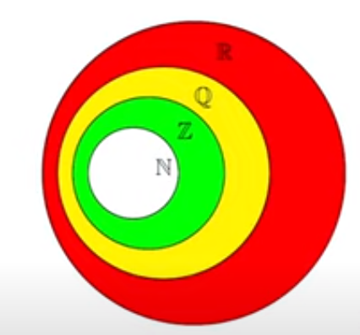
10. Every set is a subset of itself. Thus, X ⊆ X.
11. X = Y, if X ⊆ Y, and Y ⊆ X. Both sets are said to be equal to each other.
12. If all elements of Y is not present in X, but all elements of X is present in Y, then X is a proper subset of Y. It’s represented as X ⊂ Y, or X ⊊ Y
13. Set that has no elements is called empty set. Represented as ∅. This is not the same as {∅}, which is a set containing empty set.
14. ∅ ⊆ X, for every X. Every element of ∅ is part of X. This may sound strange.
15. ∅ is a subset of every set
16. If X is a subset of Y, and Y is a subset of Z, then X is a subset of Z.
17. If A is a set, then P(A) = {X : X ⊆ A} is called the power set of A. It is the set of all subsets of A. For example, if A = {a, b}, then powerset of A is {∅, {a}, {b}, {a, b}}
18. Powerset of an empty set is {∅}
19. Set of n elements has $2^{n}$ subsets. This can be proved by considering that each of the n elements may be included/excluded from the subset (2 options per element). Since 2 options are available to every element in the set, the total number of subsets is $2^{n}$
20. Subsets of a set with n elements can be thought of a binary number, where each bit decides if the element must be included (1), or excluded (0)
21. In set comprehension terms, the subset of even integers is represented as {x | x ∈ Z, x mod 2 = 0}
22. Steps used in a set comprehension are Generate, Filter and Transform. In the above case, x is generated from the set Z is generated first, then an even number filtering is applied, and finally, transforms the number into itself.
23. Set of perfect squares is represented as {x | x ∈ N, $\sqrt{x}$ ∈ N}
24. Set of rational numbers is represented as {p/q | p, q ∈ Z, $\gcd\left(p, q\right)=1$}
25. Set of cubes of all the natural numbers up to 500 is represented as { | n ∈ N, n < 500}
26. To generate a set of perfect squares, we can use the set comprehension { | n ∈ N}
27. Closed intervals are represented as []. Open intervals are represented as (). If the number of not included, use empty circle while drawing the number line.
28. Union combines both sets, without duplicating elements. A ∪ B = {x: x ∈ A or x ∈ B}.
29. Elements common in both sets is intersection. A ∩ B = {x: x ∈ A and x ∈ B}
30. X – Y and X \ Y represents set difference (or alternatively called relative complement). This results in all elements of first set that aren’t present in second. X \ Y = {x: x ∈ A and x ∉ B}
31. X \ Y ≠ Y \ X
32. Complement of primes is called composite numbers. Complement is represented as $\overline{X}$ or $X^{c}$
33. While using complement of a set, it’s important to use a reference set, called Universe.
34. Fermat’s last problem states that 2 is the only integer that can satisfy $a^{n}$ + $b^{n}$ = $c^{n}$, where a, b and c are natural numbers. When n = 2, this equation is called Pythagorean theorem.

**Relations**

1. Cartesian product of 2 sets A {0, 1} and B {2, 3} is represented as A * B = {(a, b) | a ∈ A, b ∈ B}. This will yield {(0, 2), (0. 3), (1, 2), (1, 3)}
2. Cartesian product represented as a set comprehension is called a relation. Example can be

R = {(m, n) | (m, n) ∈ N * N, n = m + 1}

This is a straight line with the y-intercept 1.

1. In the above case, R is a subset of N * N (R ⊆ N * N). It can be written using the notation (a, b) ∈ R or a R b.
2. Relation between a set of teachers T and courses C defining which teacher teachers which courses, is represented as R = {(t, c) | (t, c) ∈ T * C, t teaches c}
3. Pythagorean triplets is represented by the relation

R = {(a, b, c) | (a, b, c) ∈ N * N * N, a, b, c > 0, $a^{2 }+ b^{2 }=c^{2 }$}

1. Corners of squares is represented by Sq = {(x1, y1), (x2, y2), (x3, y3), (x4, y4) | (x1, y1), (x2, y2), (x3, y3), (x4, y4) ∈ $R^{2 }* R^{2 }* R^{2 }* R^{2 }$, points are corners of a square}
2. Identity relation can be represented in either forms below. Out of these, only the first one is technically correct.

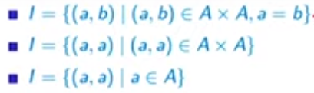

1. Reflexive relations are those that define pairs satisfying identity relation, in addition to other pairs. In this case, (a, a) pairs are also part of the relation, since a and b are greater than 0.

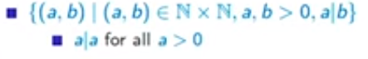

1. Symmetric relations are those that have (a, b) and (b, a) as pairs. Examples are

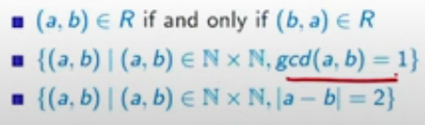

In the second case (a, b) has the same gcd as (b, a), so both pairs are part of the relation.

1. Transitive relations are those that have pairs that are of transitive nature. For example,

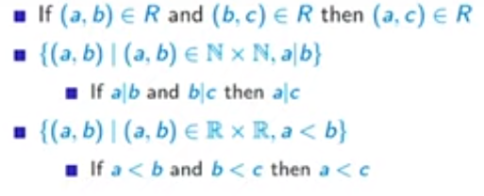

In the second case, if a is a factor of b and b is a factor of c, then a must be factor of c.

1. Antisymmetric relations are those that have pairs that do not satisfy symmetric property. For example,

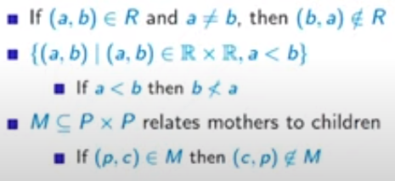

In the second case above, if a is less than b, then b cannot be less than a.

1. A relation that’s reflexive, symmetric, and transitive is called equivalence relation. An equivalence relation partitions a set. Groups of equivalent elements are called equivalence classes. For example, following is an equivalence relation.

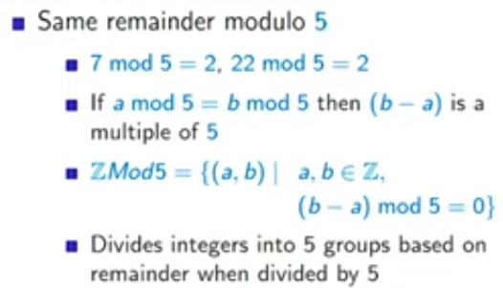

1. Set of primes P = {p | p ∈ N, factors(p) = {1, p}, p ≠ 1}

**Functions**

1. A rule to map the inputs to outputs. Example is a function that converts x to its square. Represented as x ↦ $x^{2 }$. It may be alternatively represented to as sq(x) = $x^{2 }$
2. Input of a function is called domain. Set of all possible output values is called co-domain, and actual values in the output is called range. Range is always a subset of co-domain. In the above case,

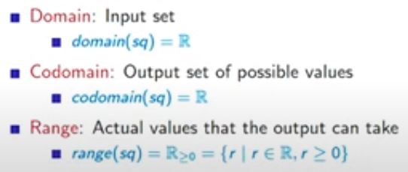

1. Every function has a relation associated with it. Properties of the relation are that it’s defined for the entire domain, and is single-valued (for every x in the domain, there’s only one y in the co-domain)
2. If a relation has two outputs for the same input, it’s not a function. Thus, square-root is a function only when considering the positive square-root of the number. Moreover, domain will depend on the co-domain. In the case of square function, co-domain is R, range is R >=0.
3. Injective functions (into) will have different y-values if x-values are different. For example, f(x) = 3x + 5 is an injective function. But, f(x) = 7 $x^{2 }$ is not. This is because, for x = 1 and x = -1, the y-value is 7.
4. Surjective functions (onto) have same range and co-domain. Thus, for every y in the co-domain, there must be an x, such that f(x) = y. For example,

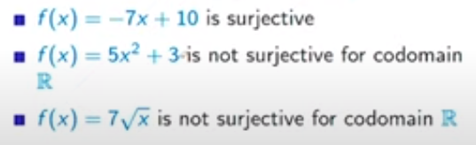

1. A function is bijective, if an only if it’s injective and subjective. Thus, for every x in domain, there’s a distinct y-value in co-domain. Also, for every y in the co-domain, there’s an x in the domain such that y = f(x)
2. domain and range same cardinality only if function is bijective. This is especially useful in case of infinite sets.
3. Functions might have no maximum/minimum, but could have local maximum or local minimum.